**CLUB REGALIA**

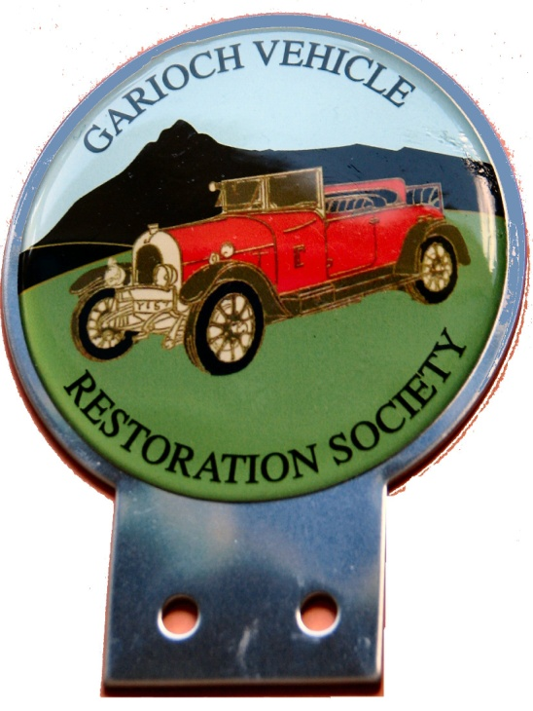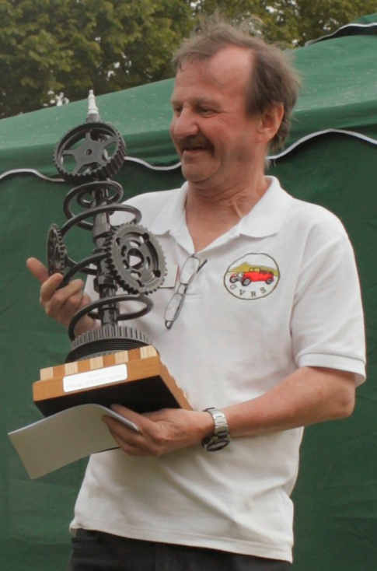

Colours & Sizes available

|  |  |  |  |  |
| --- | --- | --- | --- | --- |
| Colour | S | M | L | XL |
| Blue | Yes | Yes | Yes | Yes |
| White | Yes | No | Yes | Yes |
| Green | Yes | Yes | Yes | Yes |

Car Badge - £10 Polo Shirt - £10

Resin coated Stainless steel Without model or trophy!

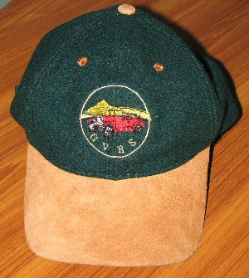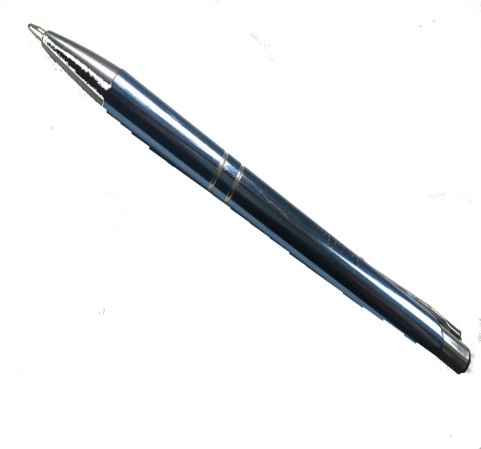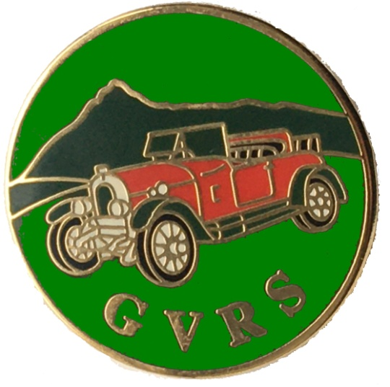

Baseball Cap - £7.50 GVRS Pen - £1.20 Lapel Badge - £2

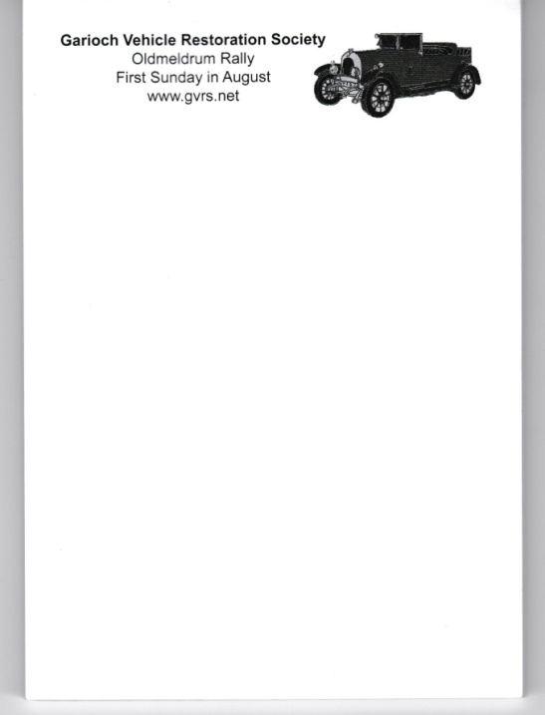

Large Hessian Shopping Bag

with GVRS Logo

(No image available)

£6

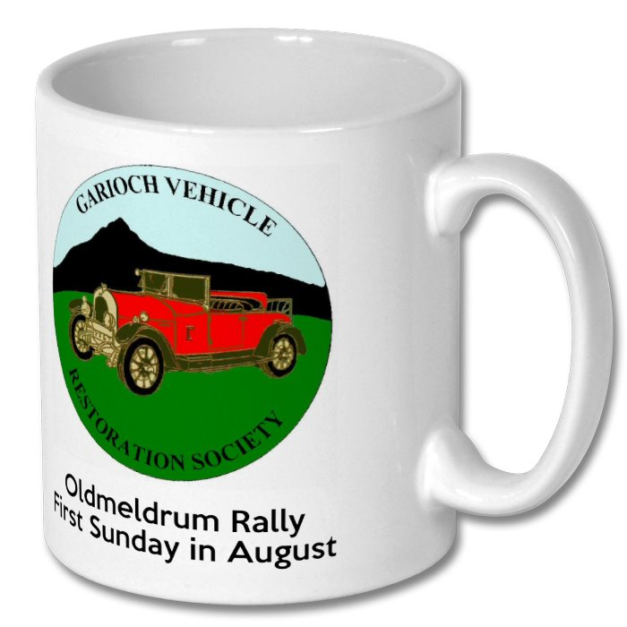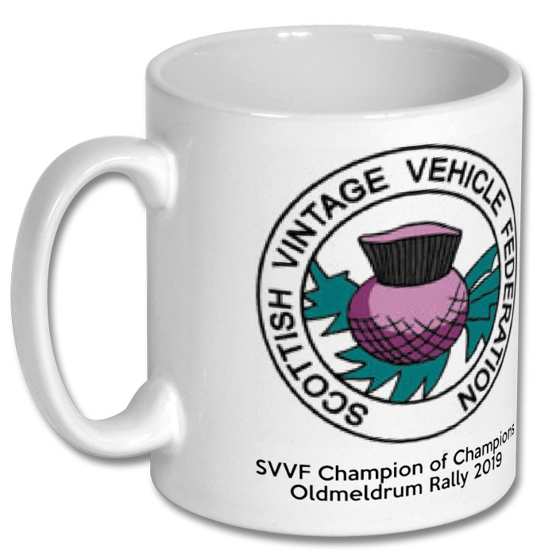

2019 Rally Mugs - £3

A6 Size Notepad - £0.50